GRANARD MUNICIPAL DISTRICT

Corporate Affairs,
Aras an Chontae,
LONGFOIRT.

15th March 2016.

Please note Venue of Meeting – ’98 Hall, Ballinamuck .

To: Each Member of Granard Municipal District.

Dear Member,

You are requested to attend Meeting of Granard Municipal District to be held in
’98 Hall, Ballinamuck on Tuesday, 22nd March 2016 at 5.00 p.m. to transact business, as set out on the Agenda hereunder.

Yours sincerely,
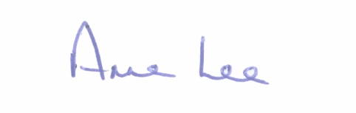

_______________
Anne Lee,
Meetings Administrator.

AGENDA

Prayer before meeting.

1. Confirmation of Minutes of the Meetings of Granard Municipal District
held on 26th January and 23rd February 2016 - copies enclosed.

2. Matters arising from Minutes.

3. Fix date for Annual Meeting of Granard Municipal District.

4. Presentation on the North Longford Rebel Trail.

5. Consideration of the 2016 Granard Municipal District Budget.

6. Consideration and adoption of Draft Municipal District Report for inclusion in Longford County Council 2015 Annual report – draft enclosed.

7. Notices of Motions submitted by Councillors, as listed hereunder -

Councillor P.J. Reilly.

“I wish to put a motion forward to the meeting for an update regarding Cnoc Mhuire Secondary School Granard's bus parking facility plans for the school, so as to remove buses parking along the main road on the N55 at a busy junction.”

“That the Council provide speed ramps in their housing estates in Granard to slow down the speed of traffic in these estates – Colmcille's Tce, Beechwood and Trumra Road.”

Councillor Paraic Brady.

“That the Council carry out a C.P.O. on lands at Killoe -
- Going from Ennybegs Village to the Graveyard.
- At the dangerous junction at the end of Ennybegs Village.”

8. A.O.B.

